Player Profile: John Ormerod
Gary Wise
The Pro Tour has all kinds of stars: the Jon Finkels and Kai Buddes who dominate, the Alex Shvartsmans and Zvi Mowshowitzs who write, the Brian Kiblers and Warren Marshes who build. These are the players who have helped make the Pro Tour what it is, and who will help it become what is can be. John Ormerod has some of the qualities of all three varieties, but he doesn't fit as easily into a niche.

"There is no doubt in my mind that John is the best deckbuilder in the world." -Ben Ronaldson
Despite attending ten Pro Tour events, Ormerod is, by his own admission, not a "Pro Tour player". Also, despite a Top 8 performance and a ninth-place finish to his credit, Ormerod has never had a strong enough season to make his way to the promise land of automatic qualification. His best season saw him earn a mere 15 pro points, and he's never strung together two consecutive money finishes on the Tour.
So why then does his name merit mention? Simple: John Ormerod is the gamer's gamer. Never the favorite, Ormerod fights his way to each Pro Tour event by winning Qualifiers or maintaining his high rating with consistently strong performances, building some of the best decks in the world as he does so. The creator of decks such as "Trinity", "Red Deck Wins 2000", and "Solution", Ormerod has become one of the best deckbuilders in the world while maintaining his amateurish outlook on the game. In other words, he doesn't play for the money: He plays for the competition and because he simply enjoys the Magic game.
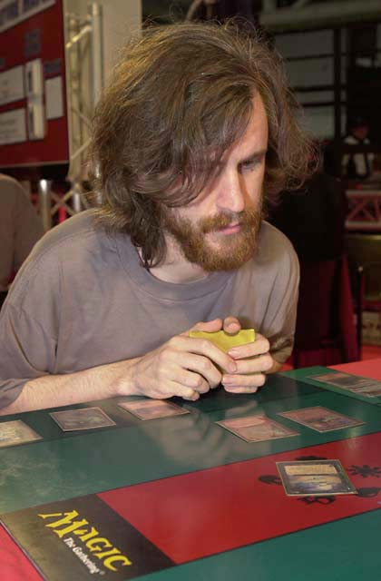
Ormerod started on his journey to the Pro Tour six years ago when university friends showed him the game. He immediately took a liking to the Magic game, finding as he does with most games that he had a natural talent for it. He immediately built a blue-black flier deck, including his first favorite card, Sengir Vampire.
Ormerod's university friends quickly fell away from the game, but his love for it kept him involved. Ormerod's experience taught him that he was "good at winning games," and his first Pro Tour Qualifier experience was no different: The software engineer made it to the Top 8 on his first try, beating Chris Manners, who was at the time considered to be England's top player, and then Richard Edbury to win a spot at Pro Tour-Mainz.
Ormerod must have thought the Magic game was pretty easy after Germany's only Pro Tour event. There, he played his way to what is still his only Top 8 performance. Ormerod, considered by most to be England's best Limited player, was finally derailed by Kurt Burgner in a blue-white mirror match in the quarterfinals.
Ormerod disappeared from the spotlight for a while, with four mediocre-to-poor Pro Tour performances before 1999 Pro Tour-Chicago. In Chicago, Ormerod, now working with the rest of the top English players, helped put his country on the map. There, Ormerod, Ben Ronaldson, Warren Marsh, and the rest of the English crew built the "Coco Pebbles" deck that was universally agreed to be the best deck at that tournament. Ormerod piloted the deck to a somewhat disappointing ninth-place finish, edged out of Day 3 on tiebreakers.
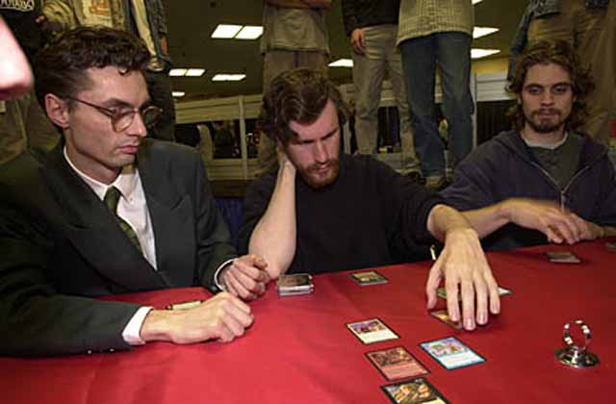
Ormerod flanked by Warren Marsh and Ben Ronaldson
Ormerod again fell out of the spotlight for the next year before starting off the 2000-2001 season with a bang. Teaming with Marsh and Ronaldson to form Team Hampton Court Palace, Ormerod finished ninth at Pro Tour-New York, further trumpeting the arrival of the English, who were now working with Kai Budde and the rest of the top German players. After New York, Ormerod made the four-hour drive from London to Manchester, where he proceeded to have one of the more dominant showings in recent Grand Prix history: He started the tournament 11-0 before drawing into the Top 8 by drafting the same kind of blue-black deck as when he began the Magic game more than five years before. At 10-0, Ormerod's teammates started urging him to drop from the tournament because his resulting ratings boost had earned him an invitation to the Pro Tour-Chicago Masters Series. Ormerod declined, feeling confident about how he was playing and wanting to do well on his home turf. His decision paid off: He eventually finished second to Darwin Kastle and maintained a high enough rating to get to Chicago.
Ormerod is now working with Team Godzilla, a Pro Tour superpower. His teammates include Kai Budde, Patrick Mello, Zvi Mowshowitz, Scott Johns, Brian Selden, and Ronaldson, among others. While his calm exterior and passion for the game make him an appealing teammate, it's his deckbuilding prowess that really makes him one of the team's most valuable contributors.
Still qualifying on a tournament-by-tournament basis, Ormerod is pretty optimistic about the future of the game. "I think that eventually some huge computer game that interests the same kind of people as Magic does will deflect people's interest. But until then, I see Magic continuing on the course it's on now," Ormerod said. Because he feels it's getting harder to qualify, one has to wonder how much time Ormerod has left in the sun. But until the rest of the English Pro Tour Qualifier circuit can stop him, it seems that this "non-Pro Tour player" will keep showing up for some time to come.

